Project name: Virtual Key for Your Repositories

**This is a prototype Application , the user interaction will be via a command line.**

**In this project it will display the welcome information and then ask for the user interaction as accessing files in the given folder, Display menu for File Operations and exit application. In Display menu options we can add, delete, search a file in the folder.**

**Given as: Please select the below options**

**1. Add File :-**

**When new file is added or Created.**

1. **Delete File :-**

**New file can be Deleted.**

1. **Search File :-**

**It checks the file is present in the directory. if the file is not found the error message is generated FILE IS NOT FOUND.**

1. **Exit Program :-**

**Application is closed & Thank You message display.**

**Github Link :- https://github.com/Aniket03-op/Project.git**

**Source Code:-**

import java.io.File;

import java.io.IOException;

import java.util.Arrays;

import java.util.Scanner;

public class Phase1 {

static String DIRECTORY;

File folder_name;

public Phase1() {

DIRECTORY = System.getProperty("user.dir");

folder_name = new File(DIRECTORY+"/files");

if (!folder_name.exists())

folder_name.mkdirs();

System.out.println("DIRECTORY : "+ folder_name.getAbsolutePath());

}

private static final String WELCOME_PROMPT =

"Phase1_Project";

private static final String MAIN_MENU_PROMPT =

"\nSelect any of the Operations: \n"+

"1.List files in directory\n"+

"2.Add, Delete or Search\n"+

"3.Exit Program";

private static final String SECONDARY_MENU_PROMPT =

" \nSelect any of the Operations: \n"+

" a.Add a file\n"+

" b.Delete a file\n"+

" c.Search a file\n"+

" d.GoBack";

void showPrimaryMenu() {

System.out.println(MAIN_MENU_PROMPT);

try(Scanner scanner = new Scanner(System.in)){

int option = scanner.nextInt();

switch (option){

case 1 : {

showFiles();

showPrimaryMenu();

}

case 2 : {

showSecondaryMenu();

}

case 3 : {

System.out.println("Thank You");

System.exit(0);

}

default: showPrimaryMenu();

}

}

catch (Exception e){

System.out.println("Please enter 1, 2 or 3");

showPrimaryMenu();

}

}

void showSecondaryMenu() {

System.out.println(SECONDARY_MENU_PROMPT);

try(Scanner scanner = new Scanner(System.in))

{

char[] input = scanner.nextLine().toLowerCase().trim().toCharArray();

char option = input[0];

switch (option){

case 'a' : {

System.out.print("↳ Adding a file...Please Enter a File Name : ");

String filename = scanner.next().trim().toLowerCase();

addFile(filename);

break;

}

case 'b' : {

System.out.print("↳ Deleting a file...Please Enter a File Name : ");

String filename = scanner.next().trim();

deleteFile(filename);

break;

}

case 'c' : {

System.out.print("↳ Searching a file...Please Enter a File Name : ");

String filename = scanner.next().trim();

searchFile(filename);

break;

}

case 'd' : {

System.out.println("Going Back to MAIN menu");

showPrimaryMenu();

break;

}

default : System.out.println("Please enter a, b, c or d");

}

showSecondaryMenu();

}

catch (Exception e){

System.out.println("Please enter a, b, c or d");

showSecondaryMenu();

}

}

void showFiles() {

if (folder_name.list().length==0)

System.out.println("The folder is empty");

else {

String[] list = folder_name.list();

System.out.println("The files in "+ folder_name +" are :");

Arrays.sort(list);

for (String str:list) {

System.out.println(str);

}

}

}

void addFile(String filename) throws IOException {

File filepath = new File(folder_name +"/"+filename);

String[] list = folder_name.list();

for (String file: list) {

if (filename.equalsIgnoreCase(file)) {

System.out.println("File " + filename + " already exists at " + folder_name);

return;

}

}

filepath.createNewFile();

System.out.println("File "+filename+" added to "+ folder_name);

}

void deleteFile(String filename) {

File filepath = new File(folder_name +"/"+filename);

String[] list = folder_name.list();

for (String file: list) {

if (filename.equals(file) && filepath.delete()) {

System.out.println("File " + filename + " deleted from " + folder_name);

return;

}

}

System.out.println("Delete Operation failed. FILE NOT FOUND");

}

void searchFile(String filename) {

String[] list = folder_name.list();

for (String file: list) {

if (filename.equals(file)) {

System.out.println("FOUND : File " + filename + " exists at " + folder_name);

return;

}

}

System.out.println("File NOT found (FNF)");

}

public static void main(String[] args) {

System.out.println(WELCOME_PROMPT);

Phase1 menu = new Phase1();

menu.showPrimaryMenu();

}

}

**Output :-**

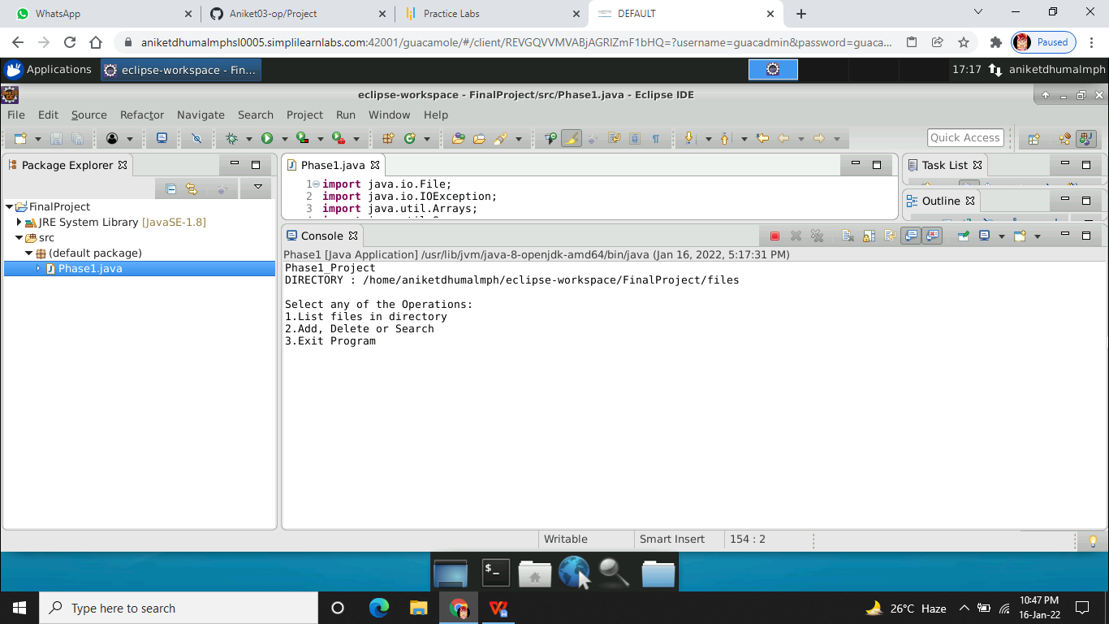

**Add File :-**

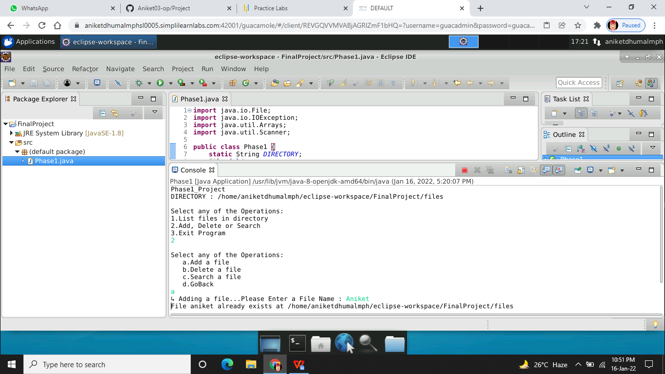

**List File :-**

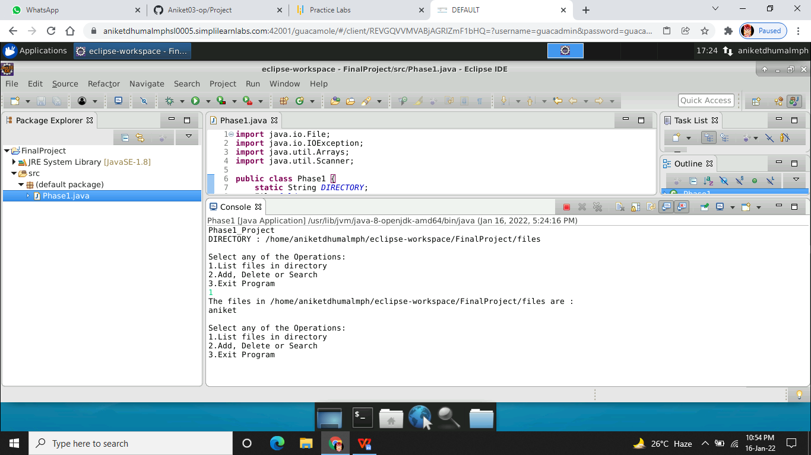

**Search File:-**

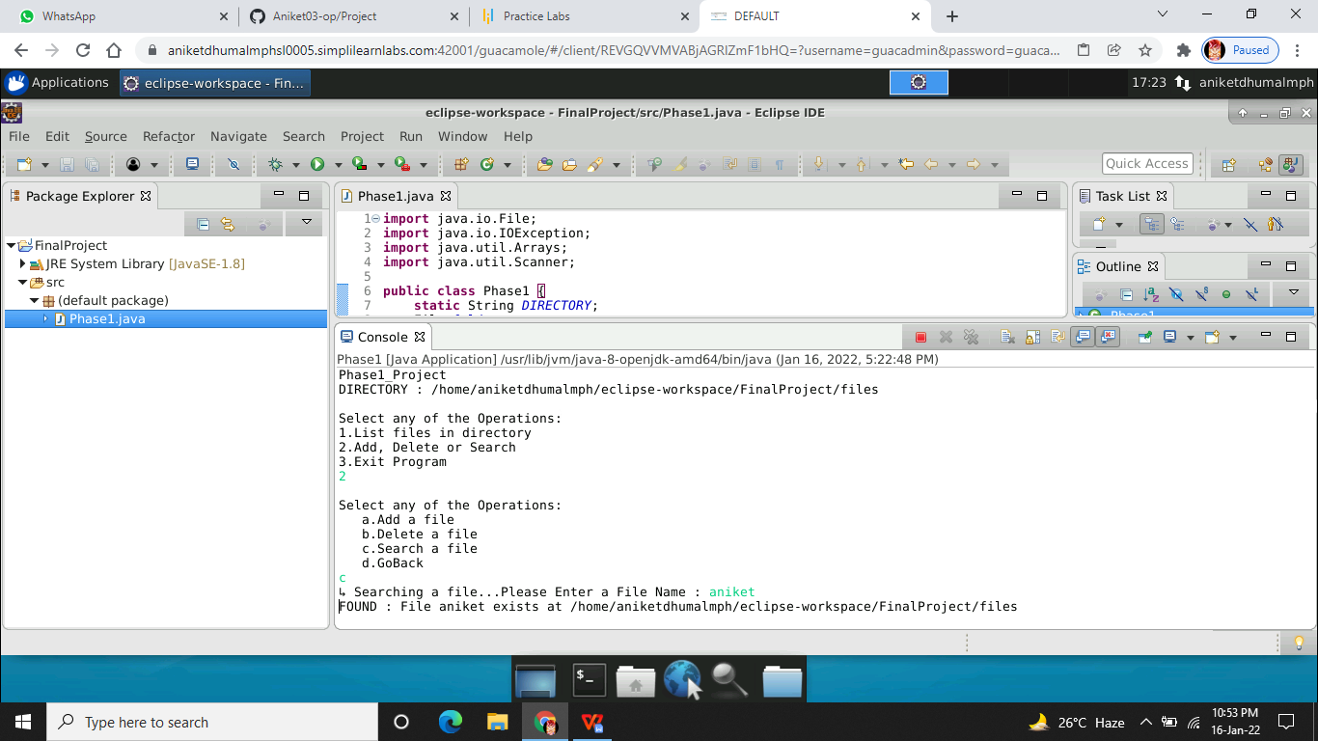

**Delete File:-**

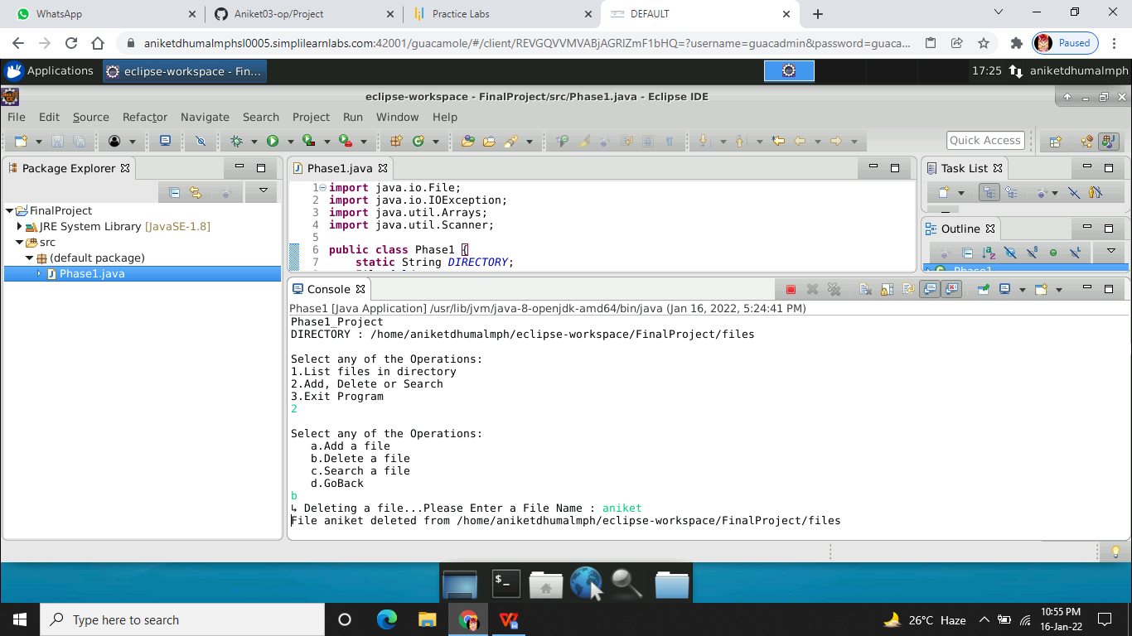

**Exit Program:-**

